Word Equations & Maths Format for the Web
….Dropbox\Quarto_GitHub_Rpubs\MathJax\Pandoc_MathJax_HTML_Jul 2026.docx

Pandoc
Download latest version of Pandoc (Windows Installer
https://pandoc.org/installing.html
pandoc-3.10-windows-x86_64.msi

Installed in C:\Program Files\Pandoc
Check pandoc version in R console with pandoc_version()
Workflow: example files available on Desktop C: Drive
C:\Users\Stephen\Documents\GitHub\sphannah.github.io\mathjax
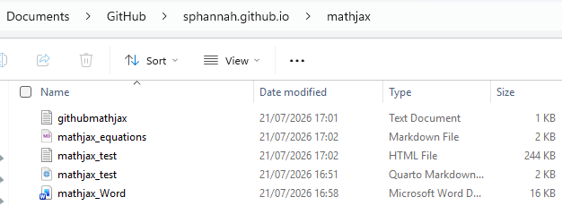

Set up equations in Word document (located on Desktop C: Drive)
Example is "…Documents\GitHub\sphannah.github.io\mathjax\mathjax_Word.docx"
Prepared commands for R Terminal (located on Desktop C: Drive)
…Documents\GitHub\sphannah.github.io\mathjax\githubmathjax.txt
-------------------------------------------------------------------------------------------------------------------------------
Html for the equations
Just paste the following into R terminal (from githubmathjax.txt)

cd C:\Users\Stephen\Documents\GitHub\sphannah.github.io
pandoc "mathjax_Word.docx" ^
--from=docx ^
--to=markdown+tex_math_dollars ^
--wrap=none ^
--output="mathjax_equations.md"

Instructions make intentions clear
- from=docx explicitly identifies the source.
- to=markdown+tex_math_dollars explicitly retains $...$ and $$...$$ mathematics.
- wrap=none prevents Pandoc from inserting cosmetic line wrapping into ordinary paragraphs.

Pandoc officially supports DOCX-to-Markdown conversion including mathematics
https://pandoc.org/demos.html

Note that in the Word document Pandoc responds to the paragraph style, not merely the font size and colour. Also try and avoid floating text boxes which may not be recognised or rendered correctly.

- Create equations with Insert → Equation, not screenshots.
- Put each display equation in its own ordinary paragraph.
- Use Word’s built-in heading styles.
- Allow prose to wrap naturally.
- Avoid floating text boxes and manually positioned objects.
- Use ordinary paragraphs for captions, notes and sources.
- Expect web fonts, colours and spacing to come from CSS, not Word.

In the Word document, be careful with manual line breaks. For responsive web paragraphs, allow Word to wrap the lines naturally rather than pressing Shift+Enter.

Extract of Markdown output (mathjax_equations.md) – view in R Studio

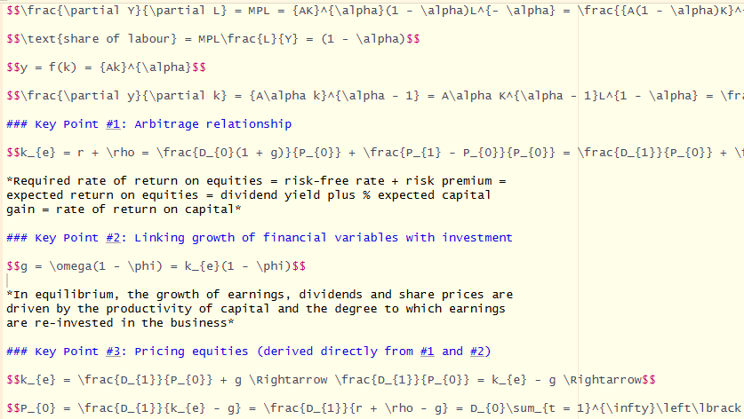

Avoid copying and pasting the Markdown
In body of .qmd file enter “Display equations” command
Also ensure YAML includes mathjax method

Typical YAML instructions for .qmd

---
title: "Based on qmd template"
subtitle: "MathJax equations from Word"
date: last-modified

format:
html:
fig-width: 10
fig-height: 6
toc: false
number-sections: false
code-fold: true
code-tools: true
embed-resources: true
html-math-method: mathjax
css: ../style.css
theme: none

execute:
echo: false
warning: false
message: false
freeze: false
---

Enter markdown command in body of .qmd file

## Display equations

{{< include mathjax_equations.md >}}

The include instruction must:
- appear on a line by itself;
- have a blank line above and below;
- point to a file relative to the main .qmd;
- include a Markdown fragment without its own YAML header.

Quarto treats an include as if its contents had been pasted into the main document.
https://quarto.org/docs/authoring/includes.html

Useful Quarto equation syntax

